By Default, login forms have a full page reload as well (same problem as <a> tag in routing). To make this a single page application first we need to prevent the default behavior of the form.

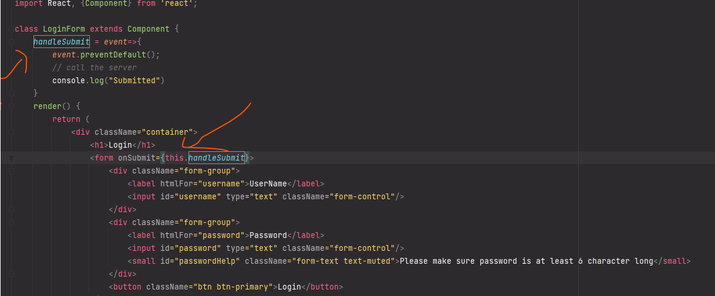

Now next step is to get the value from the form fields, but in react we must never access Dom element directly. To solve this issue, react has this attribute called ref. But we should minimize the use of Ref as a rule of thumb.

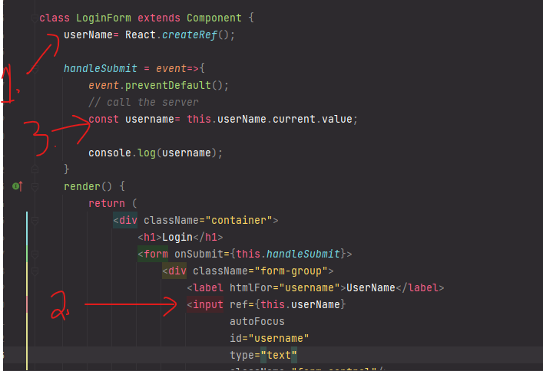

To solve this issue, we need to use controlled element.

1. First, we declare in the state two empty string of username and password.

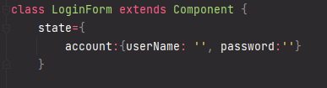

1. Then we setup the value of the input field from the state.

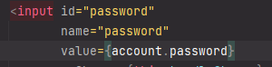

1. Then we setup a onChange event handler, which will update the state depending on the input field.

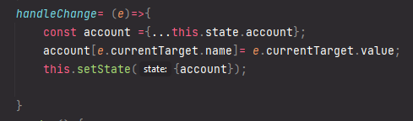

1. In this example, we must setup a name property in the input field to get access of the current input field as well.



1. Now the state will change every time we write something in the input field.

**Common errors:** not initializing the username or password for example, which will make it undefined and cause error. Another one is, setting them null, which also causes problem. So best to just leave an empty string during initialization or get data from database.

**Validation:**